Open the "Foodmart_Data_Model.xlsx" worksheet that you saved on your desktop. This file was the finished product of your previous exercises. You should first complete all the other exercises and Quests before this one. Your Sheet1 should already have the Pivot Table you created from Exercise 4.3; if not, please redo the previous assignments.

The image below is your starting point. It shows the Pivot Table you previously created.

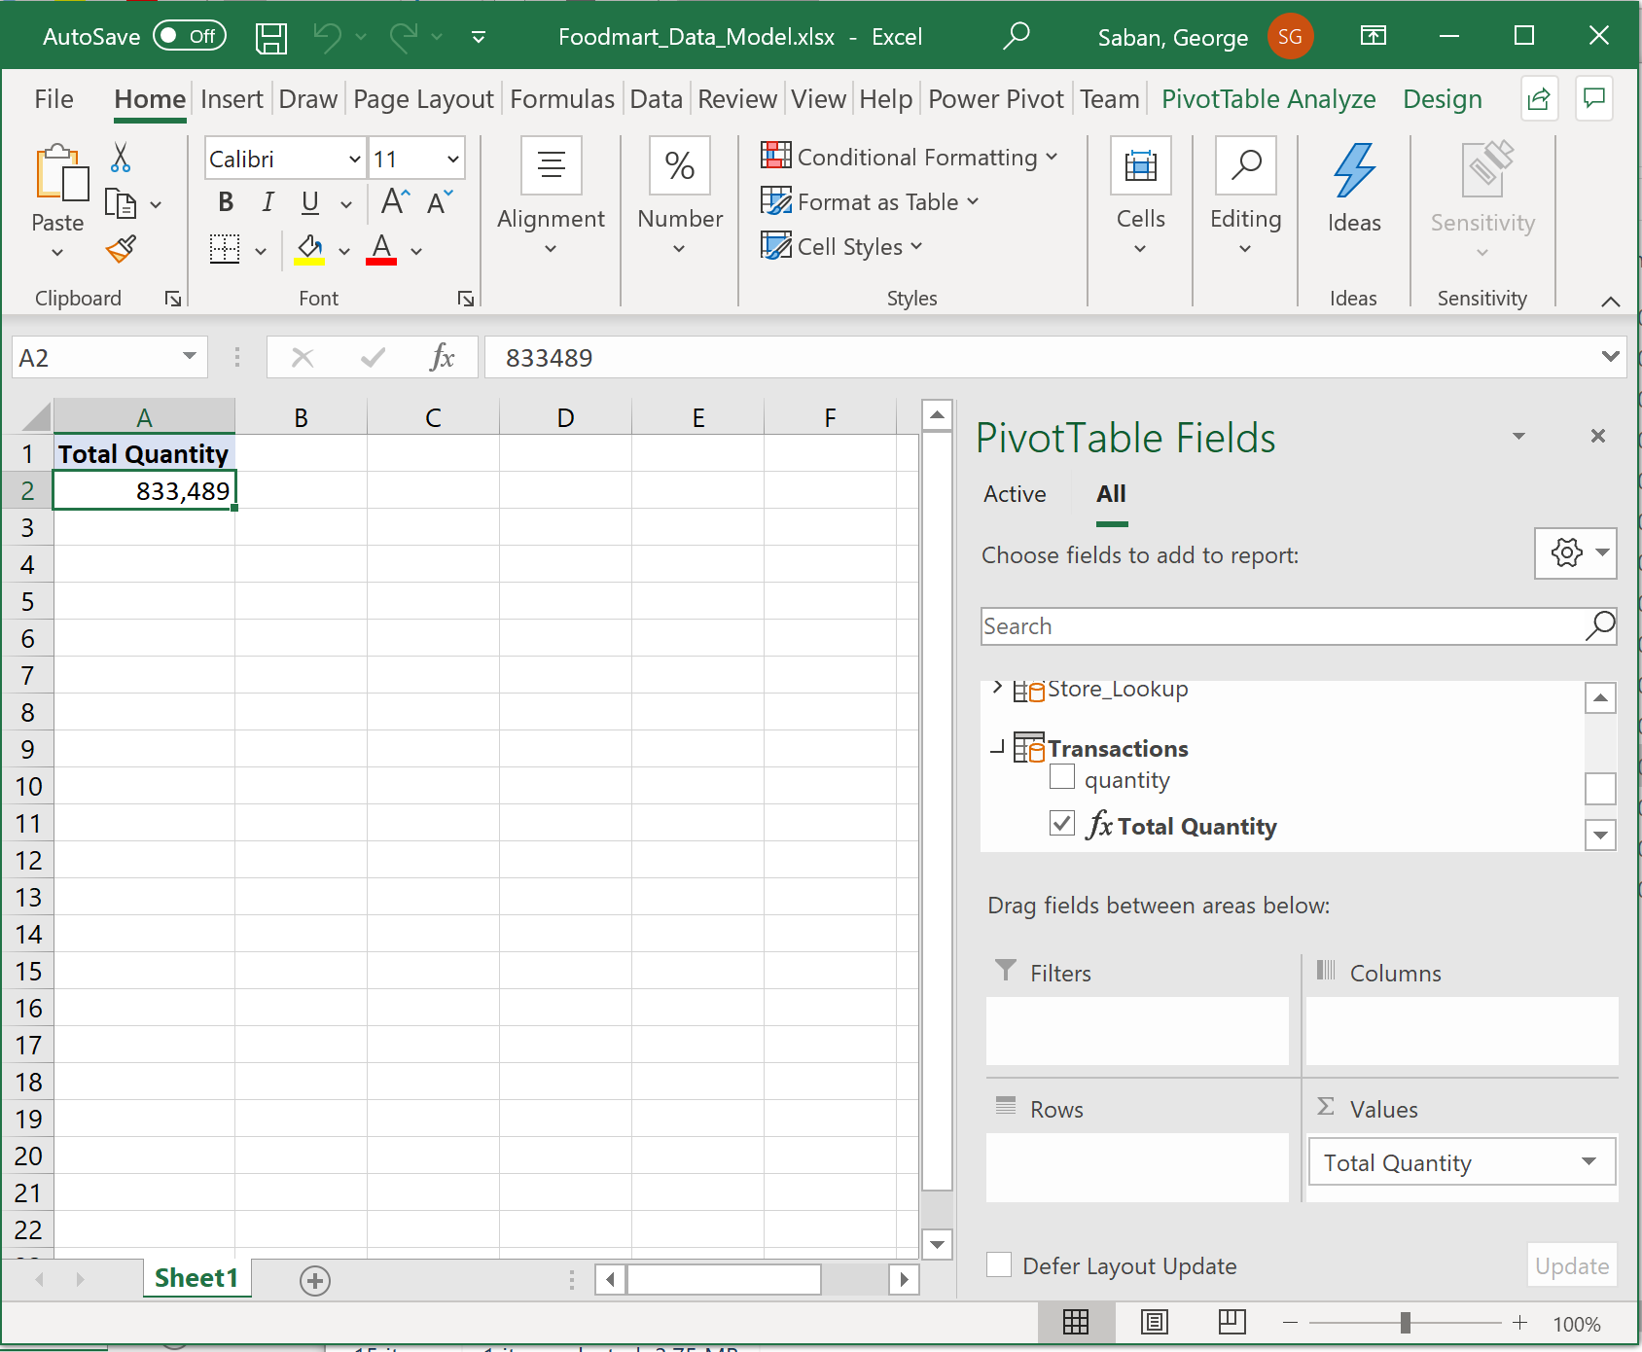

Expand Store_Lookup > More Fields > then drag store_country field to the Rows panel.

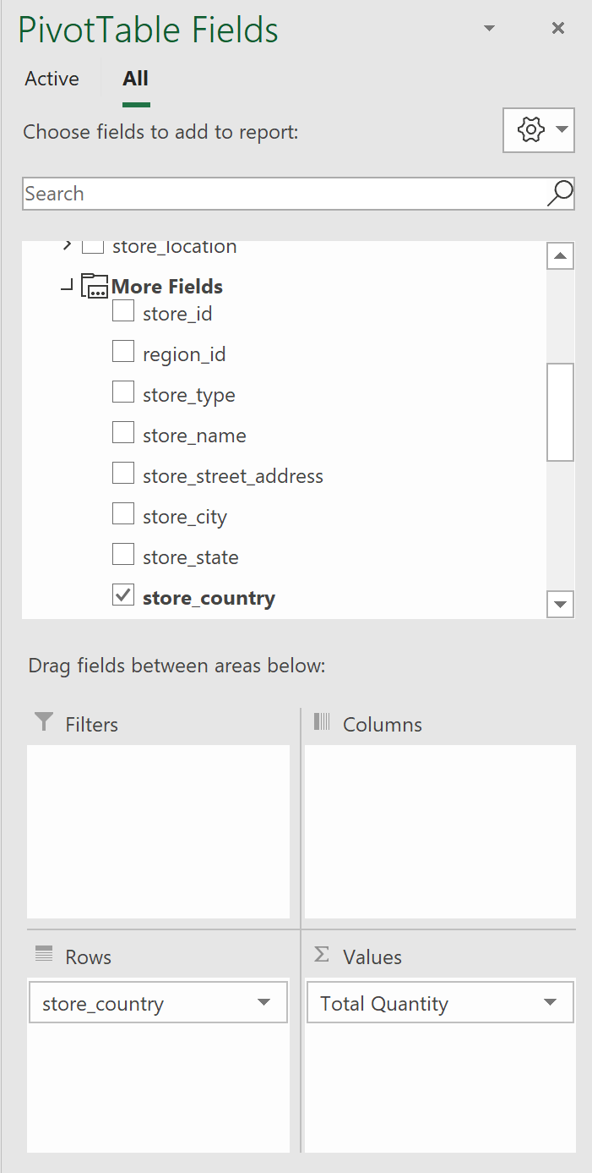 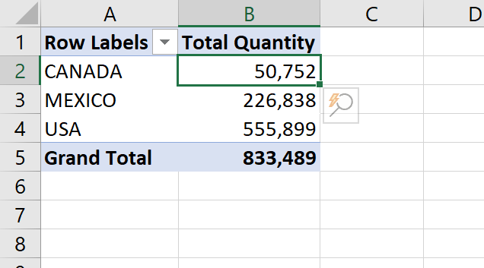



Note how the Power Pivot table changed its display with countries as row labels.

Also, the cell with value 50,752 has one coordinate: store_country=CANADA

If you don’t see the column headers, go to Design > Report Layout > Show in Outline Form.

Now, let’s access a different table: minimize Store_Lookup > expand Product_Lookup > More Fields > pull product_brand and drag it under store_country inside the Rows label > move store_country into Columns label.

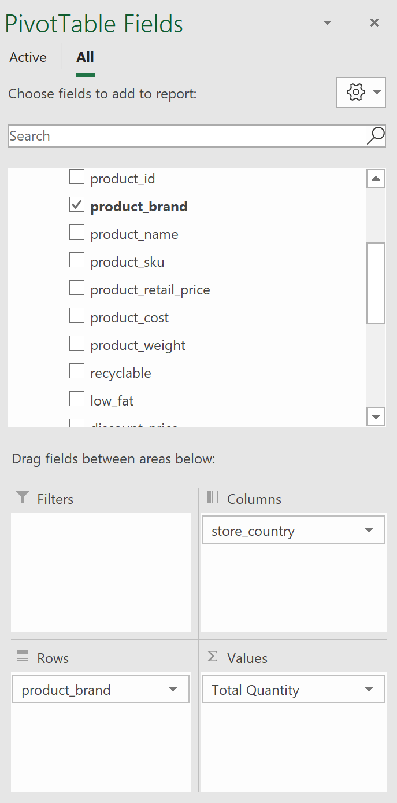 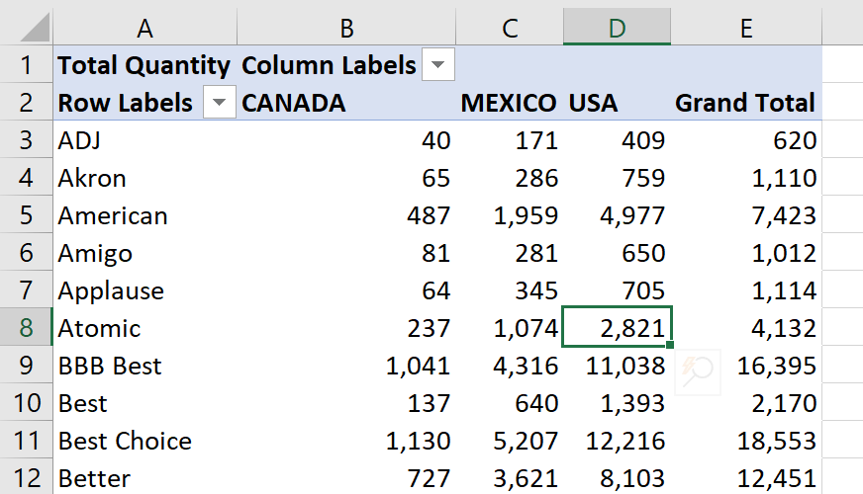



Note how the Power Pivot table changed its display with product_brand as the row labels and store_country as the column labels. Which means that the cell with value 2,821 has two coordinates: product_brand=Atomic and store_country=CANADA

Therefore, the filter context started at the two lookup tables (Product and Store) and then flowed to the transaction table, counting the total quantity for the Atomic product sold in the USA, yields 2,821.

How cool is that! Dynamic presentation of data at your fingertips!

Let’s add more fields (filters): expand Customer_Lookup > grab gender and drag it to Filters pane

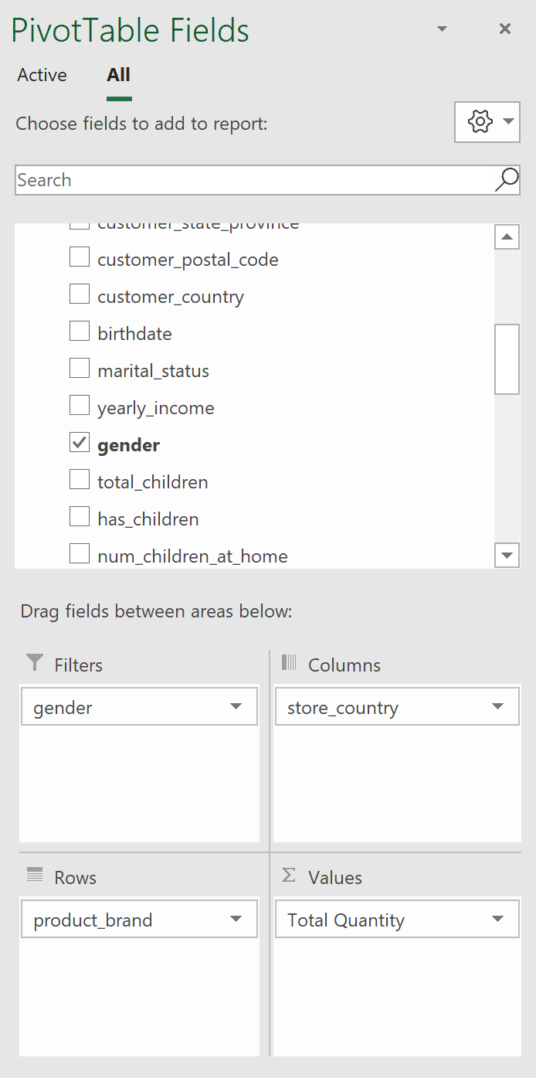 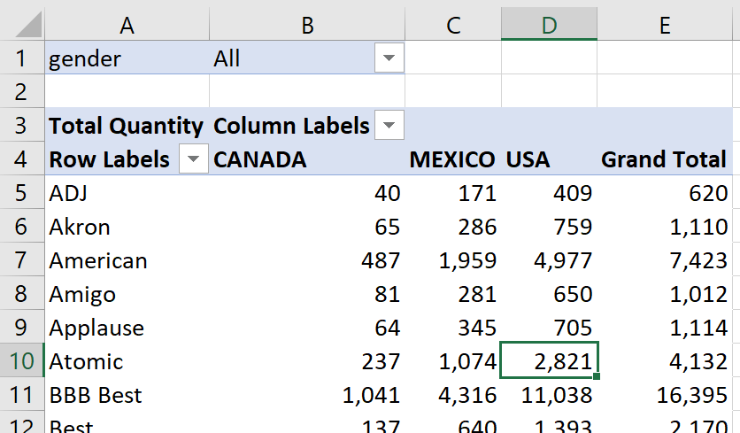



Note how the Power Pivot table changed its display. Now expand gender > expand All > select F (for Females) > click OK.

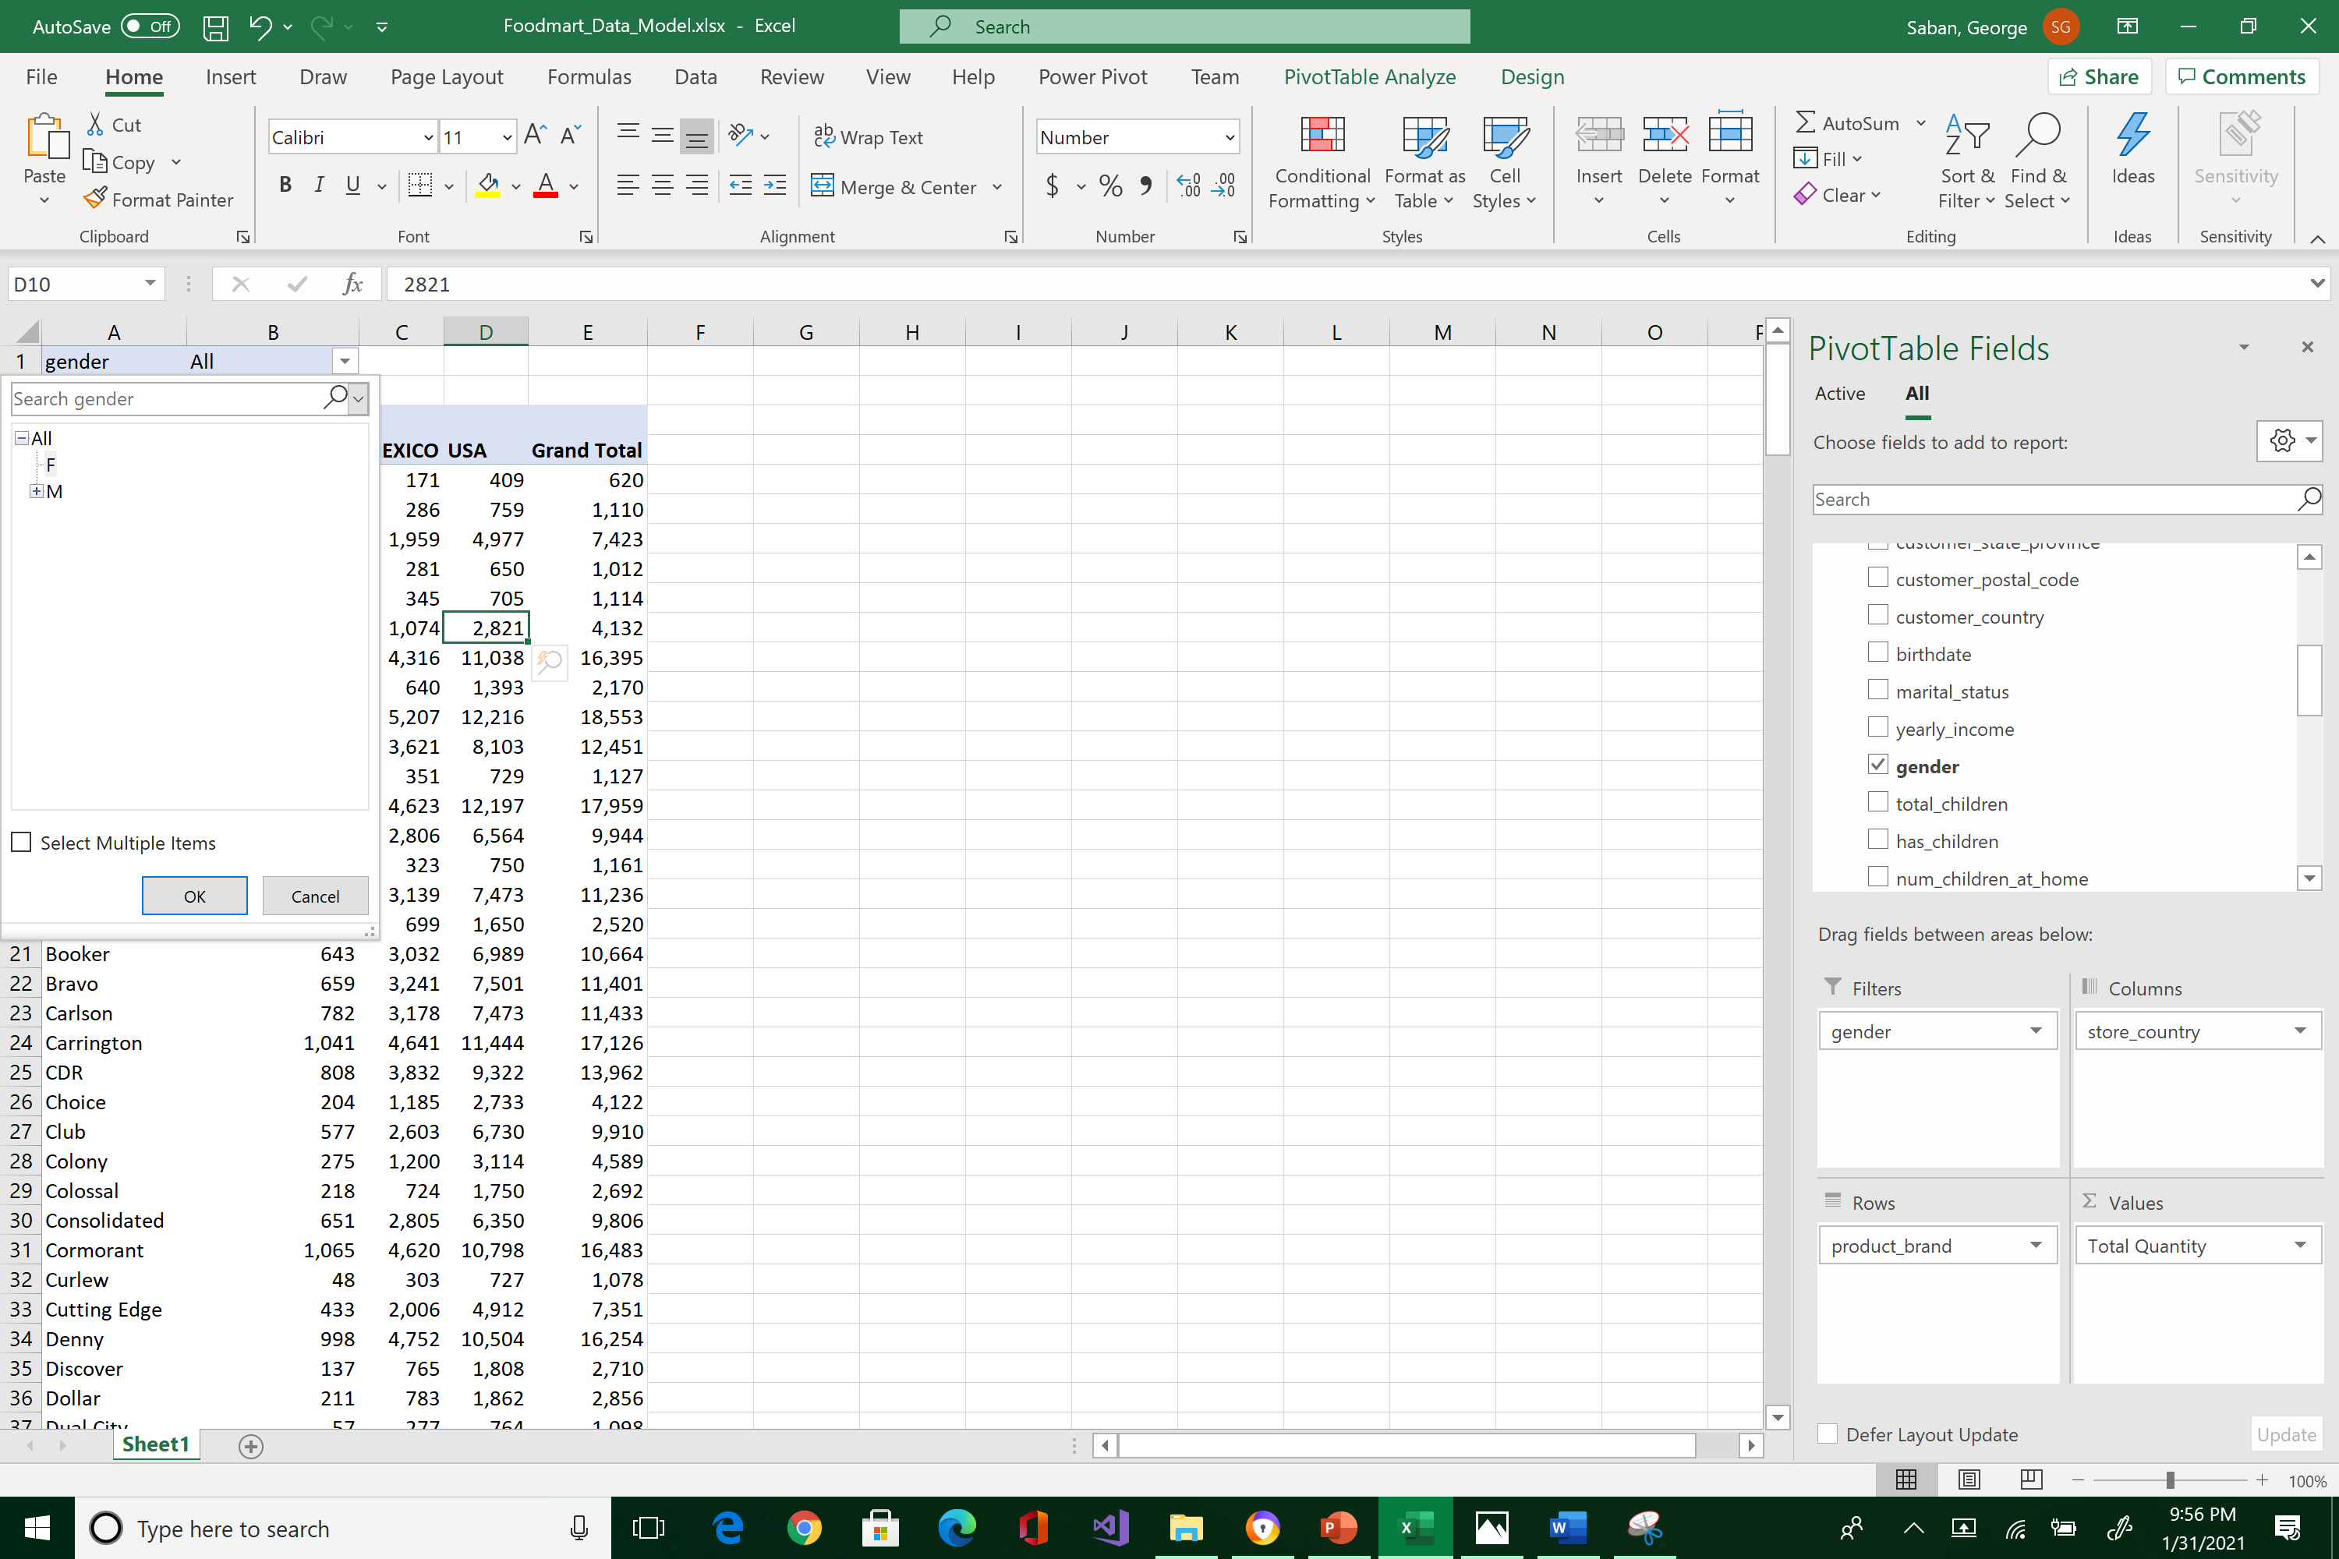



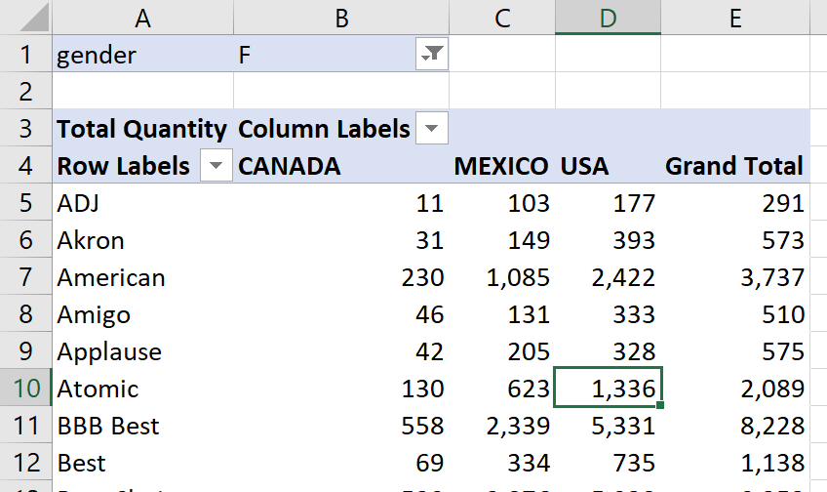



Now we have 3 coordinates for a cell. For example, product_brand=Atomic, store_country=CANADA, and gender=F

The filter context used three different lookup tables to winnow (or filter) the transaction quantity. These selection criteria, streaming down to the transaction table, decide which row will be included in the computation. That’s the idea behind filter context. Make sure you save your work.

What to submit?

Reposition your screens so that the Pivot Table is similar to the below.

1. Take a snapshot using Window's Snipping Tool.
2. Make sure the system's date, your name, and all the encircled data are included in the image.
3. Submit to Canvas in PNG format.

Thank you!

